
RAJALAKSHMI INSTITUTE OF TECHNOLOGY
(An Autonomous Institution, Affiliated to Anna University, Chennai)

DEPARTMENT OF ARTIFICIAL INTELLIGENCE AND MACHINE LEARNING
ACADEMIC YEAR 2026 - 2027
SEMESTER V
DEEP LEARNING MINI PROJECT REPORT
REGISTER NUMBER | 2117240030028  2117240030039  2117240030045
NAME | DHARRINI SELVI R  K HARINI  HARSHINI J
PROJECT TITLE | Real-Time Driver Drowsiness Detection Using Convolutional Neural Networks
DATE OF
SUBMISSION
FACULTY
IN-CHARGE
Signature of Faculty In-charge:  ______________________ |  | Signature of HoD:  ______________________

1. Project Title

CNN-Based Driver Drowsiness Detection using Deep Learning — a real-time eye-state classification system using CNN.

2. Introduction

Driver drowsiness is a major safety concern, especially during long-distance and night-time driving. Fatigue can reduce a driver's attention and reaction time, while prolonged eye closure can be an important indicator of drowsiness. Therefore, an automated system that continuously monitors the driver's eye state can help identify early signs of fatigue and provide timely warnings.

This project develops a CNN-based real-time driver drowsiness detection system using computer vision and deep learning. A webcam captures the driver's face, detects the eye regions, and classifies them as open or closed using a Convolutional Neural Network (CNN) trained on an eye-state dataset. If the eyes remain closed for a predefined duration, the system identifies the driver as drowsy and activates an audible alert to warn the driver.

3. Problem Statement

Driver drowsiness is a serious road-safety issue that can lead to reduced attention, delayed reactions, and accidents. Traditional methods of detecting fatigue rely on manual observation or vehicle-based indicators, which may not provide timely warnings. Therefore, there is a need for an automated, real-time system that can monitor a driver's eye state and detect prolonged eye closure. This project aims to develop a CNN-based deep learning system that classifies the driver's eyes as open or closed using a webcam and generates an audible alert when prolonged eye closure indicates possible drowsiness.

4. Aim / Goal
The aim of this project is to develop a real-time CNN-based driver drowsiness detection system that monitors the driver's eyes through a webcam, classifies them as open or closed, and detects prolonged eye closure. The system generates an audible alert when possible drowsiness is detected, helping improve driver safety and reduce the risk of fatigue-related accidents.
5. Objectives
- To collect and organise a labelled eye-image dataset containing open and closed eye classes.

To preprocess and augment the image data to improve model robustness to variations in eye position, lighting, and orientation.

To design a CNN architecture suitable for 64×64 grayscale eye images.

To train the CNN and monitor training and validation accuracy and loss across epochs.

To evaluate the trained model using accuracy, confusion matrix, precision, recall, and F1-score.

To integrate the trained CNN with real-time webcam-based face and eye detection.

To detect prolonged eye closure as an indication of possible drowsiness and generate an audible alert to warn the driver.

6. Background

Convolutional Neural Networks (CNNs) are widely used for image classification because their convolutional and pooling layers automatically learn important visual features such as edges, shapes, and textures, reducing the need for manually engineered features. Driver drowsiness detection using CNNs has gained attention as it provides a camera-based, non-invasive, and low-cost approach to monitoring driver fatigue without requiring specialised wearable sensors or vehicle hardware.

This project builds on this approach by training a lightweight CNN on labelled open and closed eye images. The trained model is integrated with a webcam-based system to classify the driver's eye state in real time and identify prolonged eye closure as a potential sign of drowsiness, triggering an audible warning to improve driver safety.

7. Dataset Description
Attribute | Description
Dataset | MRL Eye Dataset
Classes | Open Eyes, Closed Eyes
Training Images | 20,000 (10,000 each)
Testing Images | 1,000 (500 each)
Input | Eye images
Target | Eye State — Open / Closed
Purpose | CNN-based driver drowsiness detection

8. Data Collection
The MRL Eye Dataset was collected and organised programmatically into separate open and closed eye classes. The dataset structure was verified to ensure that the required class folders were present and that the images were correctly assigned to their respective categories. The prepared dataset was then divided into training and testing sets, providing the expected input structure before CNN model training and evaluation.

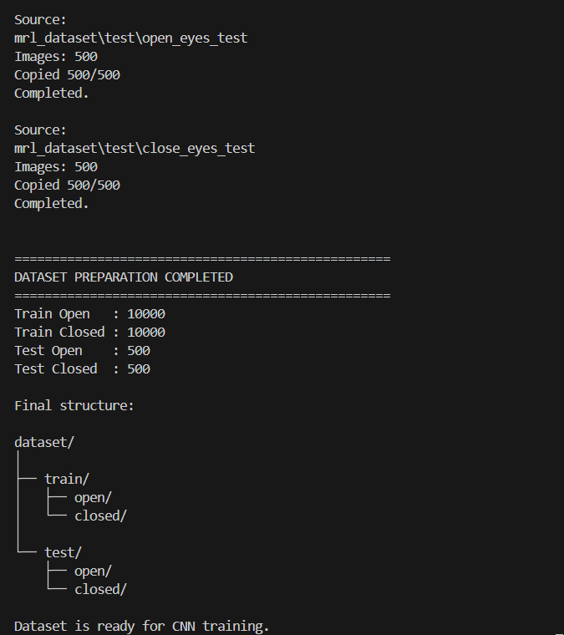

Fig. 1 — Dataset preparation output showing the distribution of open-eye and closed-eye images and the final training and testing dataset structure.

9. Data Preprocessing

Data Cleaning

The dataset was organised into two valid classes, open and closed eyes. The images were checked during dataset preparation to ensure that they were placed in the correct class folders before CNN training.

Missing Value Handling

As the dataset consists only of image files, there are no traditional missing or null feature values. The dataset structure was verified to ensure the required open and closed folders were available.

Outlier Detection

Sample eye images were visually inspected to identify any obviously corrupted or incorrectly classified images. The prepared dataset was then used for CNN training and testing.

Data Transformation

All images were resized to a uniform 64 × 64 pixel resolution and converted to grayscale. The images were loaded in batches with a batch size of 32 for efficient CNN training.

Data Encoding / Normalisation

Pixel intensity values were normalized from the [0, 255] range to [0, 1] using a Rescaling(1.0/255) layer. The two eye-state classes, closed and open, were encoded as binary labels, and binary cross-entropy was used as the classification loss.

10. Exploratory Data Analysis (EDA)
A sample of images from the open-eye and closed-eye classes was visualised in a 4×4 grid to examine the dataset and verify the correctness of class labels. The samples show variations in eye appearance, facial position, lighting, and image quality, providing an initial understanding of the data used for CNN training.
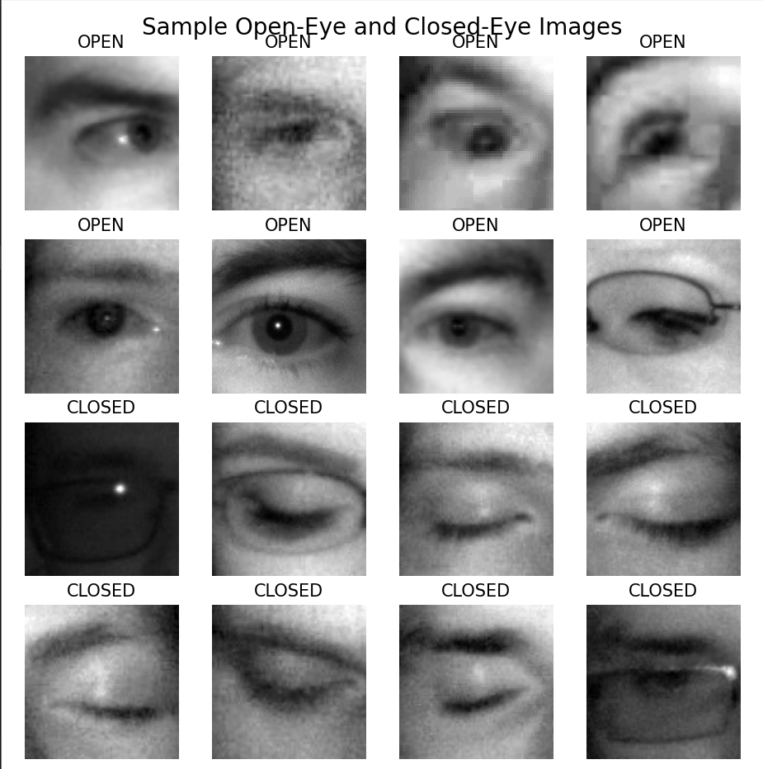

Fig. 2 — Sample training images showing open-eye and closed-eye classes.

11. Statistical Analysis
Parameter | Open Eyes | Closed Eyes | Total
Training Images | 10,000 | 10,000 | 20,000
Testing Images | 500 | 500 | 1,000
Total Images | 10,500 | 10,500 | 21,000
Class Distribution | 50% | 50% | 100%
Test Precision | 98% | 98% | —
Test Recall | 98% | 98% | —
Test F1-Score | 98% | 98% | —

12. Data Visualization
Training and validation accuracy and loss were visualized across the training epochs to monitor the learning behaviour of the CNN model. The accuracy graph shows how the model's ability to classify open and closed eyes improves during training, while the loss graph shows the reduction in prediction error. These visualizations help assess the model's learning progress and identify possible overfitting or underfitting.
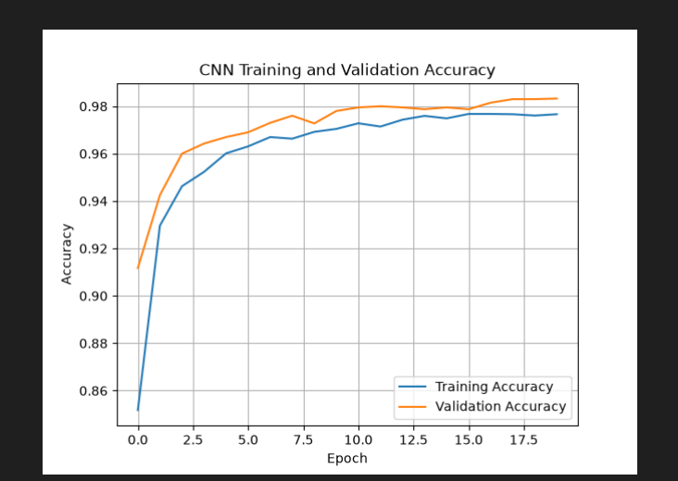

Fig. 3(a) — Training and validation accuracy across epochs
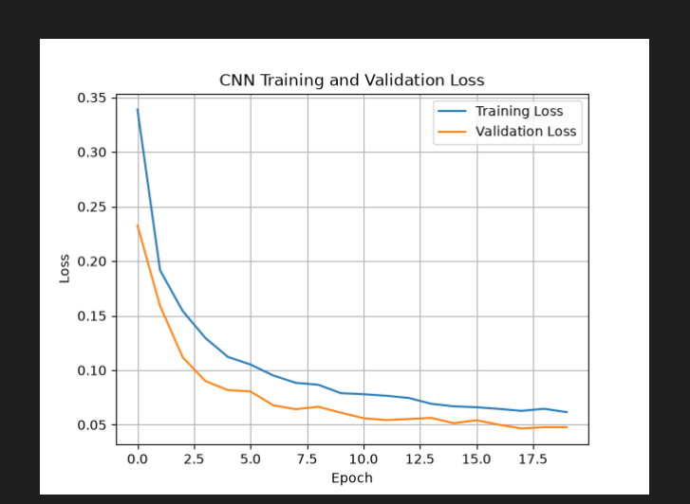
Fig. 3(b) — Training and validation loss across epochs

13. Deep Learning Technique / Model

This is a supervised binary image classification task for detecting driver drowsiness based on eye state. A Convolutional Neural Network (CNN) was developed using TensorFlow/Keras, consisting of three convolutional and max-pooling blocks with 32, 64, and 128 filters, followed by a flatten layer, a 128-unit dense layer, and dropout layers for regularisation. The final 1-unit sigmoid output layer classifies the eye as either open or closed.

The model uses the Adam optimiser with a learning rate of 0.001, binary cross-entropy as the loss function, and accuracy as the evaluation metric. Data augmentation using random horizontal flipping, rotation, and zoom was applied to improve generalisation.

14. Model Development / Analysis

The CNN model was developed and trained using the prepared dataset containing 20,000 training images of open and closed eyes. The images were resized to 64 × 64 grayscale, normalized to the range [0, 1], and augmented using random flipping, rotation, and zoom to improve generalisation. The model was trained for a maximum of 20 epochs using the Adam optimizer and binary cross-entropy loss, with Early Stopping and Model Checkpointing used to retain the best-performing model.

The trained model was evaluated on 1,000 unseen test images and achieved a test accuracy of 98.10%. The confusion matrix shows 489 correctly classified closed-eye images and 492 correctly classified open-eye images, demonstrating that the CNN effectively distinguishes between the two eye states.

15. Model Evaluation / Validation
The final trained CNN model was evaluated on the held-out test dataset containing 1,000 images, with 500 open-eye and 500 closed-eye images. The model achieved a test accuracy of 98.10% and a test loss of 0.0558, demonstrating strong classification performance on unseen eye images. A confusion matrix was generated to analyse the classification performance of the two eye-state classes, along with a classification report containing precision, recall, and F1-score for detailed evaluation.

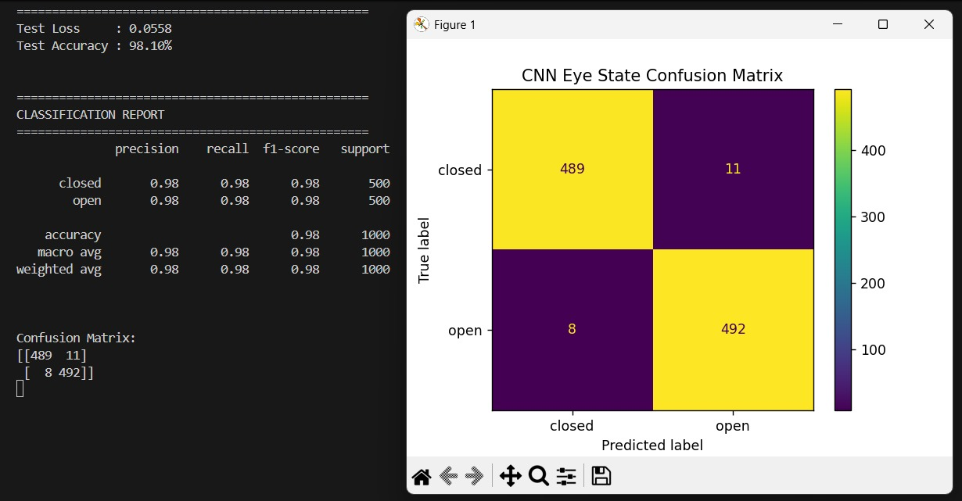Fig. 4 — Confusion matrix of the CNN model for open-eye and closed-eye classification.

16. Key Insights

The lightweight 3-block CNN achieved strong performance in distinguishing between open-eye and closed-eye images, demonstrating that a relatively simple architecture can be effective for eye-state classification.

Data augmentation and dropout helped improve the model's ability to generalise to unseen eye images and reduce the risk of overfitting during training.

The model achieved a test accuracy of 98.10%, with balanced performance for both open and closed eye classes.

The confusion matrix showed that 489 closed-eye images and 492 open-eye images were correctly classified, indicating reliable classification performance on the test dataset.

The trained CNN can be integrated with real-time webcam-based eye detection to monitor prolonged eye closure and provide an audible warning for potential driver drowsiness.

17. Recommendations / Applications

Deploy the trained CNN with a real-time webcam interface to continuously monitor the driver's eye state and detect prolonged eye closure.

Improve the real-time detection system by using better eye-region detection, temporal analysis, and confidence-based predictions to reduce false drowsiness alerts.

Integrate the system into vehicles or driver-monitoring applications to provide timely audible warnings when signs of drowsiness are detected.

Extend the system using larger and more diverse real-world datasets, including different lighting conditions, facial appearances, camera angles, and driving environments, to improve real-world performance.

Since the system requires only a standard webcam and computer, it provides a low-cost, non-invasive solution for driver fatigue monitoring without requiring specialised wearable sensors.

18. Implementation
The trained CNN model is saved as models/drowsiness_cnn.keras and integrated into a Flask-based real-time webcam application. The application performs the following steps in sequence:
- Loads the trained CNN model from disk.
- Captures live video frames using the webcam.
- Detects the driver's face and eye regions using OpenCV Haar Cascade classifiers.
- Preprocesses the detected eye images by converting them to grayscale and resizing them to 64 × 64 pixels.
- Passes the processed eye images through the CNN to classify them as open or closed.
- Monitors consecutive closed-eye frames to identify prolonged eye closure.
- Displays the eye-state and drowsiness status on the live video feed.
- Activates an audible alarm when prolonged eye closure indicates possible drowsiness.
This provides a real-time, camera-based implementation of the trained CNN model for driver drowsiness monitoring. A sample run of the Flask application is shown below.
$ python predict.py test_images/my_A.jpg ==================================================
SIGN LANGUAGE PREDICTION ==================================================
Predicted Letter : A
Confidence : 99.7% ================================================== Top 3 Predictions:
A : 99.7% ...
...
==================================================

19. Results and Discussion

The trained CNN achieved a test accuracy of 98.10% with a test loss of 0.0558 on the 1,000-image test dataset. The classification report showed 98% precision, recall, and F1-score for both open-eye and closed-eye classes. The confusion matrix also showed that 489 closed-eye images and 492 open-eye images were correctly classified, demonstrating that the CNN performs effectively in distinguishing the two eye states. These results indicate that the developed CNN provides a strong foundation for real-time driver drowsiness detection based on prolonged eye closure.

20. Limitations

The model is trained only to classify static eye images as open or closed and does not directly analyse other physiological or behavioural signs of drowsiness.

The real-time detection performance may decrease under poor lighting, occlusion, glasses, different camera angles, or variations in face and eye position that differ from the training images.

The current system relies on Haar Cascade face and eye detection, which may occasionally fail to detect the eyes correctly or produce inaccurate eye regions.

Although the CNN achieved 98.10% test accuracy on the prepared dataset, its performance may differ on completely new real-world webcam images because of differences between the dataset and live camera conditions.

The system identifies drowsiness primarily through prolonged eye closure, so short eye closures such as normal blinking must be distinguished from sustained closure.

21. Future Enhancements

Incorporate facial landmarks and advanced eye-tracking techniques to improve eye detection and reduce false predictions.

Experiment with transfer learning models such as MobileNet or EfficientNet to improve robustness while maintaining real-time performance.

Add blink-rate and eye-closure duration analysis to distinguish normal blinking from prolonged drowsiness.

Collect additional real-world webcam images under different lighting conditions, camera angles, facial appearances, and environments to improve model generalisation.

Integrate the system with vehicle safety systems or mobile/edge devices to provide real-time drowsiness alerts in practical driving environments.

22. Tools and Technologies Used
Tool / Technology | Purpose
Python 3 | Primary programming language
TensorFlow / Keras | CNN model building, training, and evaluation
OpenCV | Face and eye detection and real-time webcam processing
NumPy | Image array and numerical operations
Matplotlib | Training accuracy and loss visualization
scikit-learn | Confusion matrix and classification report
Pillow (PIL) | Image loading and preprocessing
Flask | Real-time web application and webcam interface
Visual Studio Code / Antigravity | Code development and project execution
Git & GitHub | Version control and project hosting

23. Project / GitHub Link

The complete source code, trained CNN model, results, and documentation are available on GitHub.

GitHub Repository: https://github.com/harinik1510/DL_MINI_PROJECT

The repository contains the dataset preparation, CNN training, model evaluation, and real-time drowsiness detection files.

24. Conclusion

This project successfully developed and evaluated a CNN-based driver drowsiness detection system for classifying eye images as open or closed. The model achieved a test accuracy of 98.10% on 1,000 test images, demonstrating strong performance in eye-state classification.

The complete pipeline includes dataset preparation, image preprocessing, CNN training, model evaluation, and real-time webcam-based detection. The system monitors prolonged eye closure and generates an audible alert, providing a practical and low-cost approach for real-time driver drowsiness monitoring.

25. References
- LeCun, Y., Bengio, Y., & Hinton, G. “Deep Learning.” Nature, 2015.
- Goodfellow, I., Bengio, Y., & Courville, A. Deep Learning. MIT Press, 2016.
- Abadi, M., et al. “TensorFlow: A System for Large-Scale Machine Learning.” OSDI, 2016.
- Krizhevsky, A., Sutskever, I., & Hinton, G. E. “ImageNet Classification with Deep Convolutional Neural Networks.” NeurIPS, 2012.
- Howard, A. G., et al. “MobileNets: Efficient Convolutional Neural Networks for Mobile Vision Applications.” 2017.
- MRL Eye Dataset. “MRL Eye Dataset for Open and Closed Eye Classification.”
- TensorFlow/Keras Documentation. “TensorFlow: An End-to-End Open Source Machine Learning Platform.”
- OpenCV Documentation. “Open Source Computer Vision Library.”

